Английский язык
6 класс

(ФИО)
Задание 1. Парадное крыльцо Дворца

№ 1. In the fresco inside the portico, you can see the triumphant people of different jobs and nationalities living in the _________.
- The Union of Soviet Socialist Republics;
- The Russian Federation;
- The Russian Soviet Federative Socialist Republic.
№ 2. You can also see some recognizable buildings in the fresco. Look through the photos and choose the ones in the emblazonment:
1) | 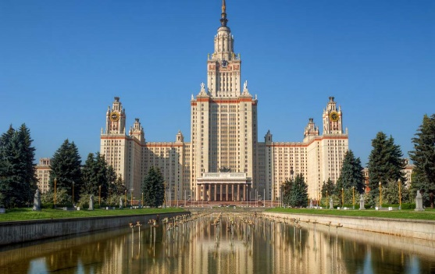Moscow State University | 2) | 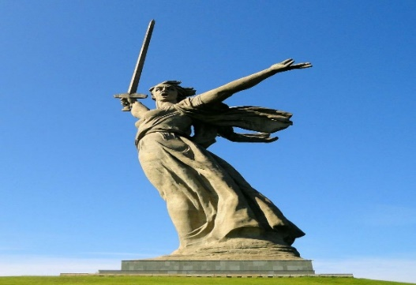  The Motherland call
3) | 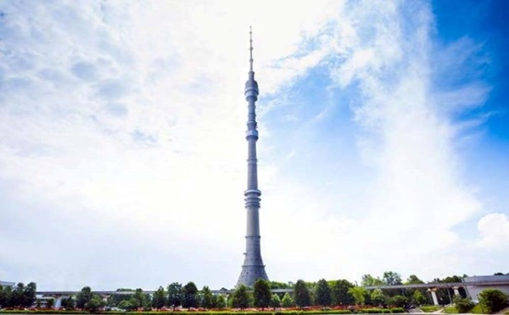  Ostankino Tower | 4) | 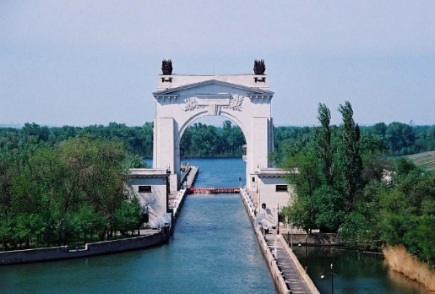Lenin Volga-Don  Shipping Canal

№ 3. Decorations also include some frets reflecting the _________ and _________ revolution in the country. Choose two variants:
- industrial;
- space;
- agricultural.

Задание 2. Зона мастер-классов
№ 1. Writing. Fill in the gaps to complete the letter for your English-speaking friend Nick.
Moscow
Russia
01/09/2019

_ _ _ _ Nick,
Thank you for your _ _ _ _ _ _. It was great to hear from you!
In your letter you asked me about an identity card. Well, here in Russia we don’t have ID cards. We have _ _ _ _ _ _ _ _ _. This is the main document which we use to certify our identity. Each person gets a _ _ _ _ _ _ _ _ at the age of _ _. It’s very _ _ _ _ to do it. You just have to come to a Multifunctional Centre of Public and Municipal Services.
I’m 12 years old now so I’m going to get mine in 2 years. I am looking forward to it!
That’s all for now. My favorite TV programme is starting.
Write back_ _ _ _!
_ _ _ _ wishes,
_______________

Задание 3. Вестибюль (голографическая инсталляция «Современная Россия»)

№ 1. Watch the virtual installation and choose the correct answer.
1. The Multifunctional Center for Provision of State and Municipal Services has improved the comfort of service / its existence / the minimum terms dramatically.
2. These centres are a modern registration/ benefit / service and a chance to have public services.
3. Such centers are a different level / place / case of providing help.
4. Multifunctional Center is the place where people enjoy their working / free / leisure time.
5. The period of issuing a document takes a lot of / plenty / some days.

Задание 4. Зона артефактов «До 1722», «1722–1917» и «После 1917»
№ 1. Match the objects with their pictures and definitions:
a picture | an object | a defnition
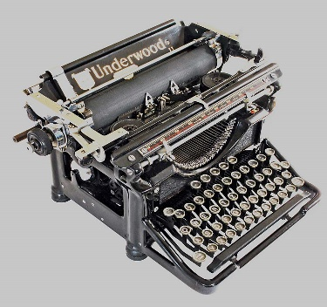 | 5 | a)
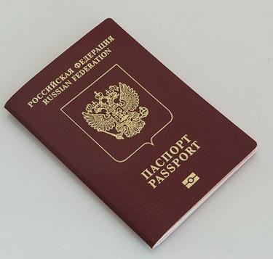
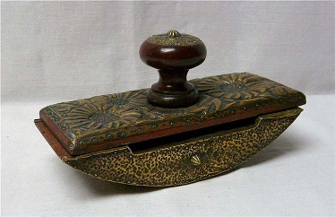
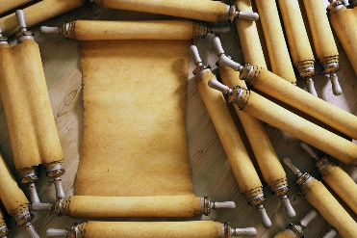
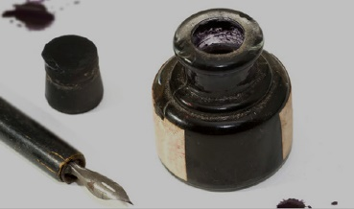
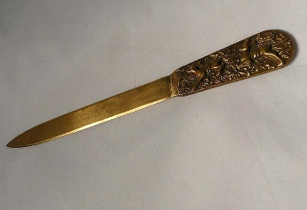

1. Parchment.
2. Ink.
3. A passport.
4. A paper knife.
5. A typewriter.
6. A presse papier.

a) A machine with keys for producing letters, numerals, and typographical symbols on paper put round a roller.
b) An official document issued by a government to certify identity and citizenship.
c) A coloured fluid or paste used for writing, drawing or printing.
d) A thin material made from the prepared skin of an animal, usually a sheep or goat, and used instead of paper in ancient and medieval times.
e) A tool used for opening envelopes.
f) A small, heavy object for keeping papers in place.
Голографические вентиляторы

№ 7. Fill in the gaps with the information you can find on display.
The Uniform of the State Bank Official
This __________appeared thanks to the establishment of a Loan Bank. In 1804, Emperor Alexander I approved new uniforms for bank clerks. The ___________ color became official for them, and the pale yellow color of the __________, lapels and cuffs (lapels on sleeves) became purple. The senior ranks now had silver embroidering on the collar, cuffs and pockets. And the famous Bank symbol – two __________ of plenty with a bee – appeared on the ______________.
The Uniform of a Woman-operator
Women-operators were the _____________ women in the Russian Empire who were allowed to work as telegraph operators. That happened in 1865. A telegraph operator was a person who received and sent telegrams. The main skills for that work were good knowledge of the ____________ language, arithmetic and good handwriting. Women-operators wore ____________ coats made of thick fabric, trimmed with
____________ welt. It was fastened with two rows of white metal buttons, which were decorated with a special symbol - a telegraph sign, made of two __________ crossing one another. Later crossed post horns were added.
Задание №5. Конференц-зал
№ 8. Watch the video and mark the statements as ‘True’ or ‘False’.
You will see the number of the window where the specialist is ________
a) in a registration book b) on the screen c) on the intitation card
Until the 17th century the text was written with ________.
a) a charcoal b) crayons c) a quill
In the 18th century bondmen without ________ letters were arrested.
a) official b) personal c) roadway
In the 19th century _________ was required for leaving abroad from Russia.
a) a passport b) a gramota c) a birth certificate
The exit visa was required for a trip abroad in _________.
a) the GDR b) Russia c) the USSR

